In This Issue:

1. Tonight’s agenda

Sudoku

Important Information

1. Speaker Profile

Structure Profile

1. Scholarships/Internships

Schedule

Sudoku Answers

**Introductions:**

Practitioner Advisors: Dave Karnowski

Peter Clark

Honorary Lifetime

Contact Member: Bob Thorn

Faculty Advisors: Dr. Melhem

Dr. Riding

**Officer Reports:**

President: Jennifer Sommerfeld

*jsommer@ksu.edu*

Vice President: Vincent Studer

*studerv@ksu.edu*

Treasurer: James Scott

*jamesds@ksu.edu*

Secretary: Michael Stancic

*sumadinac316@ksu.edu*

Editor/Historian: Claudia Gonzalez

*claudi1@ksu.edu*

Freshman/Sophomore Rep: Yadira Porras

*yaporras@ksu.edu* Activities/Projects Chair: Noura Saadi

*nsaadi@ksu.edu*

Steel Bridge Chairs: Robert Schweiger

*rschwei2@ksu.edu*

Cale Armstrong

*cagolf91@ksu.edu*

Concrete Canoe Chairs: Katlyn Dotson

*kattydid@ksu.edu*

Nathan Pohl

*pohl@ksu.edu*

Open House Chairs: Ben Nye

*nye@ksu.edu*

Nicholas Clow

*nickclow@ksu.edu*

Caleb Mitchell

*caleb7@ksu.edu*

**Agenda:**

Announcements: Jennifer Sommerfeld

Introduction of Speaker: Vince Studer

Speaker(s): Steve Hammerschmidt &

Chad Banka

TranSystems

Important Information

**Students must become national members to receive credit for ASCE Student Membership.** Registration is **free** and can be done online at http://www.asce.org/

Click “login” at the top of the page, then click “click here to create one” and follow the instructions to become a national member.

**If you are not currently enrolled in CE015, please do so in order to receive credit for attendance. Class Number: 10581**

**FE Review** manuals are available for purchase. Contact James Scott if you are interested in purchasing the manual.

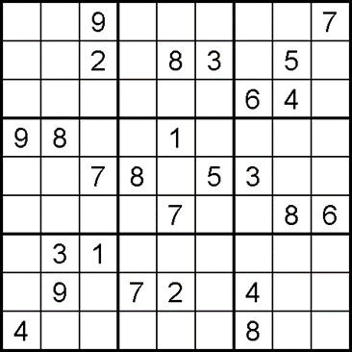

*

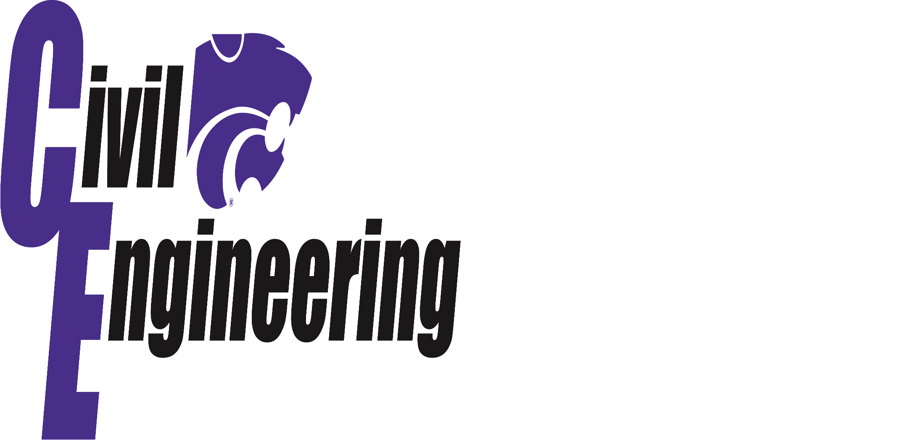

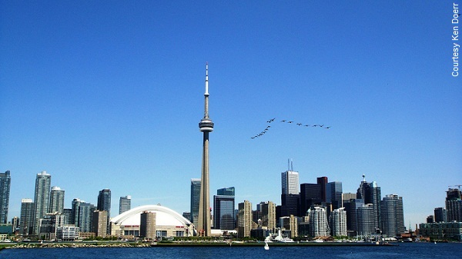

**CN Tower**

The world's tallest free-standing structure soars 1,815-feet above the sidewalks of Toronto, three times the height of its better-known cousin, the Seattle Space Needle. The CN Tower, as heavy as 23,214 large elephants, was erected at an amazing rate of 18-feet per day. During construction, concrete flowed from the bottom of the tower as it ascended, while aircraft-type bombsights kept the tower plumb as it went up. Today the tower is off by a mere 1.1-inch. Designed with the aid of a wind tunnel, the CN Tower can withstand 260-mph gusts.

The SkyPod, a seven-story structure, 1,100-feet high, was built around the base of the tower and jacked into place as one unit. A pair of 10-ton counterweights is attached to the mast to keep the tower from swaying too much. A Sikorsky helicopter hoisted the crowning antenna, for which the tower was originally erected. Radio signals are broadcast from the base of the antenna, while television signals are sent from the top. Presently, 16 of Toronto's media signals are transmitted from the tower.

**

**Steven Hammerschmidt,**

Structural Engineer

**Chad Banka,**

Roadway Engineer

TranSystems

**Steven Hammerschmidt** is a Structural Engineer for TranSystems out of the Cleveland, Ohio office. He graduated from Kansas State University with a B.S. and M.S. in Civil Engineering emphasis in Structural Engineering in December 2008, and August 2010. Steven has been working for TranSystems since graduating from Kansas State. He specializes in the areas of bridge inspection, load rating, and rehabilitation of complex structures. Currently, Steven is a Bridge Inspection Team Leader and member of a team of engineers that utilizes SPRAT rope access techniques to access complex structures with the ability to gain hands on access to all primary members of a structure.

**Chad Banka** is a Roadway Engineer in TranSystems’ Wichita office. Chad graduated with his B.S. in Civil Engineering from Kansas State University in May 2010 and began working for TranSystems shortly after. Working in Wichita provides Chad with unique opportunities for professional growth and development as his typical projects vary from simple bike paths to complex highway design. Currently, Chad is a project engineer and oversees Wichita’s Intelligent Transportation System, a growing technology that improves the safety and efficiency of road users. He currently lives in west Wichita with his wife, Cassie, and their 10-month-old son, Carson. Chad will be at the career fair next Wednesday and hopes to see you there!

**Have suggestions/ideas on how to improve your ASCE chapter or newsletter?**

Contact Claudia Gonzalez at [claudi1@ksu.edu](mailto:claudi1@ksu.edu) or any of the other officers listed on page 1.



Scholarships/Internships

**Scholarships**

*February 10th, 2014*

* B. Charles Tiney Memorial ASCE Student Chapter Scholarship
* CI Student Scholarship
* Lawrence W. and Francis W. Cox Scholarship
* John Lenard Civil Engineering Scholarship
* Robert B. B. and Josephine N. Moorman Scholarship
* Samule Fletcher Tapman ASCE Student Chapter Scholarship
* Y.C. Yang Civil Engineering Scholarship

*March 1st, 2014:*

* Kansas Chapter of the American Concrete Institute 2014 Scholarship
* 2014 National Daniel W. Mead Student Contest

*May 1st, 2014:*

* Kansas Chapter of the American Public Works Association: Steve Webb Memorial Scholarship

Applicants must be enrolled as an undergraduate student at Kansas State University in a curriculum which could possibly lead to a career in Public Works. Preference will be given for Civil Engineering students.

Applicant must be in good academic standing with respect to the requirements established by the School of Engineering at the University.

Applicant must be classified as a junior or senior for the year in which they receive the scholarship and must be enrolled in a minimum of 12 credit hours each semester.

**Internships/Jobs**

[Riley County Summer Internship](http://www.rileycountyks.gov/jobs)

**For more information on these scholarships and internships, visit** [**http://www.engg.ksu.edu/asce/**](http://www.engg.ksu.edu/asce/) **and click on the “Bulletin Board” tab.**

Schedule

|  |  |  |
| --- | --- | --- |
| February 6 | **Assembly** | Umberger 105 |
| February 11-12 | **Career Fair** | Student Union |
| February 20 | **Assembly** | Umberger 105 |
| March 6 | **Assembly** | Umberger 105 |
| March 27 | **Spring Picnic** | TBD |
| April 4-5 | **Open House** |  |
| April 17 | **Assembly** | Umberger 105 |
| May 1 | **Assembly** | Umberger 105 |

**DATES SUBJECT TO CHANGE**

|  |  |
| --- | --- |
|  |  |

**Sources:**\*Sudoku puzzle from sudokucollection.com   
**http://www.asce.org/People-and-Projects/Projects/Seven-Wonders/CN-Tower/