In This Issue:
- Tonight’s agenda
Sudoku
Important Information
- Introduction
Roger N. Post and Matthew D. Holopirek
- Schedule for Fall 2014
Sudoku Answers

Introductions:
Practitioner Advisors: Dave Karnowski
Peter Clark
Honorary Lifetime
Contact Member: Bob Thorn
Faculty Advisors: Dr. Esmaeily
Dr. Riding
Officer Reports:
President: Vincent Studer
studerv@ksu.edu
Vice President: Claudia Gonzalez
claudi1@ksu.edu
Treasurer: Jacob Paperi
jpaperi@ksu.edu
Secretary: Bryan Harkrader
bhark@ksu.edu
Editor/Historian: Yadira Porras
yaporras@ksu.edu
Freshman/Sophomore Rep: Brett Morey
bmorey@ksu.edu Activities/Projects Chair: Mary Madden
marymadden@ksu.edu
Caleb Mitchell
caleb7@ksu.edu
Steel Bridge Chairs: Eric Hamilton
eric29@ksu.edu
Donald Powers
dlpowers@ksu.edu
Concrete Canoe Chairs: Jacquelyn Ewald
jkewald@ksu.edu
Darren Meyer
djmeyer@ksu.edu
Open House Chairs: Ben Nye
nye@ksu.edu
Koby Slaven
kslaven@ksu.edu
George Baker
georgefbaker@ksu.edu

Agenda:

Announcements: Vince Studer
Introduction of Speaker: Claudia Gonzalez
Speaker(s): Roger N. Post
Matthew D. Holopirek

Important Information
Students must become national members to receive credit for ASCE Student Membership. Registration is free and can be done online at http://www.asce.org/
Click “login” at the top of the page, then click “click here to create one” and follow the instructions to become a national member.

If you are not currently enrolled in CE015, please do so in order to receive credit for attendance. Class Number: 10581

FE Review manuals are available for purchase. Contact Jacob Paperi if you are interested in purchasing the manual.

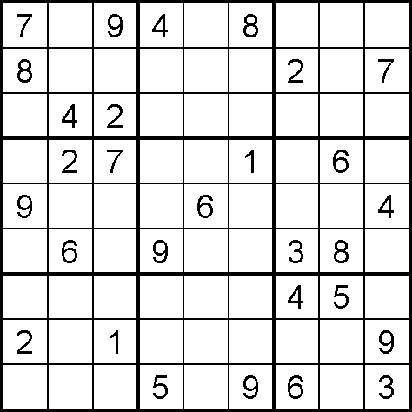
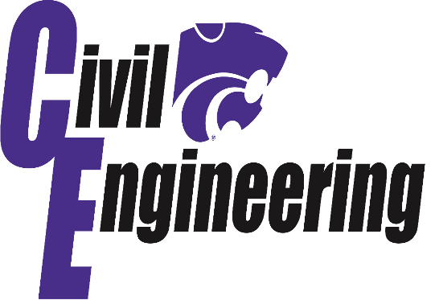

Armour-Swift-Burlington Bridge
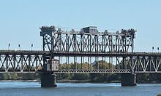
Kansas City, Missouri
Completed 1911
Claim to Fame: The Armour-Swift-Burlington Bridge is a unique, telescoping vertical-lift, steel-truss bridge that spans the Missouri River at Kansas City and is representative of the innovative moveable bridges designed by leading bridge engineer John Alexander Low Waddell
Work began in 1887 on the high-level truss "Winner Bridge" crossing the Missouri River at Kansas City. The piers were completed in 1890, but for financial reasons the project was suspended. John Alexander Low Waddell, renowned civil engineer, prepared an alternate design for a lift bridge in 1895, which would ultimately be built as the Armour-Swift-Burlington Bridge.
The Armour-Swift-Burlington encompassed many new innovations, primarily to take advantage of advances in materials and construction practices, like using riveted steel. It was the first bridge in Kansas City to provide separate rights-of-way for pedestrians, wagons, electric railways, freight trains, and motor traffic. It helped the city maintain its role as a railroad hub, permitted the railroads to expand their service, and opened up North Kansas City to development.

Roger N. Post, PE
Roger is a 1988 graduate of KSU with a BS in Civil Engineering. He is a Principal and Senior Vice President at TranSystems a Kansas City, MO based Transportation Engineering firm. Roger has spent his entire career with TranSystems and has been primarily focused on construction
management of heavy highway, rail, and airport projects. As a principal and client manager of the firm, Roger’s duties include business development and the operational expansion of heavy construction management services throughout the Midwest and Texas regions. Additionally he is assisting with the nationwide expansion of these service lines. Roger resides in Overland Park KS with his wife Ellie and his son Jordan. Roger’s daughter Elissa is in her
final semester at KSU!

Matthew D. Holopirek, PE
Matt is a Construction Engineer/ Construction Team Leader for TranSystems, a Kansas City, MO based Transportation Engineering firm. Matt graduated from KSU with a BS in Civil Engineering in December of 2003. Matt is currently serving as the lead Construction Manager of the $130M, South Lawrence Trafficway project. He also serves as a project manager for several other heavy highway construction projects throughout the metro region. Prior to rejoining TranSystems in 2013, Matt held numerous positions for Archer-Western Contractors during more than 7 years of employment while on projects in Arizona and California.
Matt currently resides with his wife Kelli in Olathe, KS.

Sources:
*Sudoku puzzle from Sudokucollection.com
** http://www.asce.org/People-and-Projects/Projects/Landmarks/Armour-Swift-Burlington-Bridge/
Schedule

September 4 | Assembly | Umberger 105
September 11 | Assembly | Umberger 105
October 2 | Picnic | TBA
October 9 | Assembly | Umberger 105
October 23 | Assembly | Umberger 105
October 30 | Assembly | Umberger 105
November 13 | Joint Dinner | KSU
November 20 | Assembly | Umberger 105
 | DATES SUBJECT TO CHANGE
DATES SUBJECT TO CHANGE

Solution for last assembly’s Sudoku:

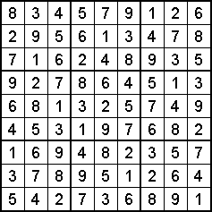

2014 AMG STRUCTURAL
The AMG structural engineering scholarship:
Requirements:
- Enrolled as a full-time student
- Prove a GPA of 3.0 or higher
- Major in a field related to structural engineering
- Be involved in at least one extracurricular activity-including service groups, professional/engineering clubs, social societies, volunteer programs, or other noteworthy extracurricular involvement
Application due October 1st 2014 (See the KSU ASCE webpage bulletin board for more information!)

Scholarship Opportunity

Fold and tear here

---------------------------------------------------------------------------------------------------
Name: _________________________________________
Class Rank: FR SO JR SR (circle one)
Date: September 11, 2014

Student Member: Y / N (circle one)
National Member: Y / N (circle one)
National Number: _______________________

