In This Issue:

1. Tonight’s agenda

Sudoku

Important Information

1. Speaker Profile

Structure Profile

Sudoku Answers

**Introductions:**

Practitioner Advisors: Dave Karnowski

Peter Clark

Honorary Lifetime

Contact Member: Bob Thorn

Faculty Advisors: Dr. Melhem

Dr. Riding

**Officer Reports:**

President: Jennifer Sommerfeld

*jsommer@ksu.edu*

Vice President: Vincent Studer

*studerv@ksu.edu*

Treasurer: James Scott

*jamesds@ksu.edu*

Secretary: Michael Stancic

*sumadinac316@ksu.edu*

Editor/Historian: Claudia Gonzalez

*claudi1@ksu.edu*

Freshman/Sophomore Rep: Yadira Porras

*yaporras@ksu.edu* Activities/Projects Chair: Noura Saadi

*nsaadi@ksu.edu*

Steel Bridge Chairs: Robert Schweiger

*rschwei2@ksu.edu*

Cale Armstrong

*cagolf91@ksu.edu*

Concrete Canoe Chairs: Katlyn Dotson

*kattydid@ksu.edu*

Nathan Pohl

*pohl@ksu.edu*

Open House Chairs: Ben Nye

*nye@ksu.edu*

Nicholas Clow

*nickclow@ksu.edu*

Caleb Mitchell

*caleb7@ksu.edu*

**Agenda:**

Announcements: Jennifer Sommerfeld

Introduction of Speaker: Vince Studer

Speaker(s): Seniors

Important Information

**Students must become national members to receive credit for ASCE Student Membership.** Registration is **free** and can be done online at http://www.asce.org/

Click “login” at the top of the page, then click “click here to create one” and follow the instructions to become a national member.

**If you are not currently enrolled in CE015, please do so in order to receive credit for attendance. Class Number: 10581**

**FE Review** manuals are available for purchase. Contact James Scott if you are interested in purchasing the manual.

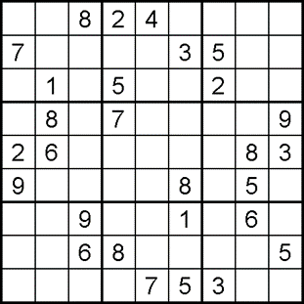*

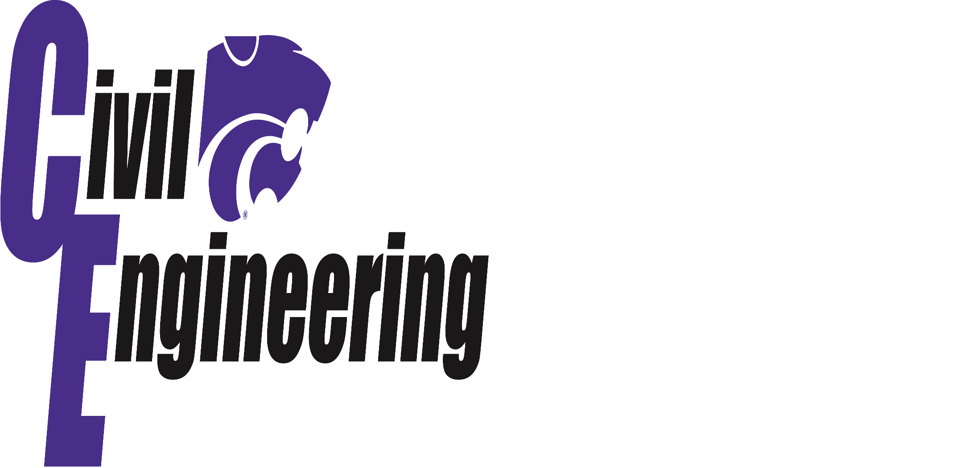

**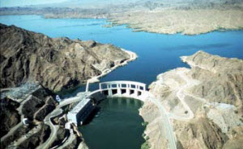   
Colorado River Aqueduct**

The 242-miles Colorado River Aqueduct made the large scale population and economic growth of Southern California possible. Constructed between 1933 and 1941, this aqueduct was selected in 1955 as one of ASCE's original "Seven Modern Civil Engineering Wonders" because of its unprecedented cost, length, pumping rate, and lift as well as its construction under conditions of severe climate and difficult terrain. The aqueduct was named an ASCE National Historic Civil Engineering Landmark in 1994.**

Each semester a new project is given to graduating seniors to simulate a real world design project. Once the problem was given to the students the class was divided into teams. Members of each team worked together to complete the following tasks:

**Task 1:** Civil and Utilities. A site plan will need to be developed to accommodate the proposed amendment. Of particular importance are modification related to storm drainage; public access, traffic, and circulation; and water line and sanitary sewer improvements. Design and construction aspects must be completed in accordance with all applicable City rules and regulations including, but not limited to, the City of Manhattan Standard Specifications.

**Task 2:** Structure and Foundations. The structural aspects include the determination of the design loads and the material(s) of choice for construction, and the design of different structural components (the main elements) that will be used in the structural system. The foundation aspects include identification of soil properties, selection of type of foundations, and the design of these foundations.

**Graduating Class of Fall 2014**

|  |  |  |
| --- | --- | --- |
| Manhal Aboalsaman | Jase Hartenbower |  |
| Mohammed Almohammedali | Weston Loehr |  |
| Robert Behm | Benjamin McCoy |  |
| Andrew Bernica | Austin Muck |  |
| Carmen Borau Ramos | Tyler Penfield |  |
| Joseph Burgett | Nathan Pohl |  |
| Nicholas Clow | Alexander Roe |  |
| Aaron Cossel | Taylor Smith |  |
| Katlyn Dotson | Lucas Spaich |  |
| Ashley Green | Andrew Spencer |  |
| Alexander Griffiths | Matthew Tye |  |
| Travis Gunter | Peiran Wang |  |

Fold and tear here

**------------------------------------------------------------------------------------------------------------------**

**Name**: _________________________________________

**Class Rank**: FR SO JR SR (circle one)

**Date**: May 1, 2014

**Student Member**: Y / N (circle one)

**National Member**: Y / N (circle one)  
 **National Number**: _______________________

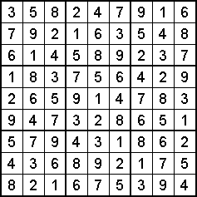*  
*http://sudokucollection.com/sp/Sudokux.html  
**http://www.asce.org/People-and-Projects/Projects/Seven-Wonders/Colorado-River-Aqueduct,-California/