In This Issue:
- Tonight’s agenda
Sudoku
Important Information
- Speaker Profile
Structure Profile
- Scholarships/Internships
Schedule
Sudoku Answers

Introductions:
Practitioner Advisors: Dave Karnowski
Peter Clark
Honorary Lifetime
Contact Member: Bob Thorn
Faculty Advisors: Dr. Melhem
Dr. Riding
Officer Reports:
President: Jennifer Sommerfeld
jsommer@ksu.edu
Vice President: Vincent Studer
studerv@ksu.edu
Treasurer: James Scott
jamesds@ksu.edu
Secretary: Michael Stancic
sumadinac316@ksu.edu
Editor/Historian: Claudia Gonzalez
claudi1@ksu.edu
Freshman/Sophomore Rep: Yadira Porras
yaporras@ksu.edu Activities/Projects Chair: Noura Saadi
nsaadi@ksu.edu
Steel Bridge Chairs: Robert Schweiger
rschwei2@ksu.edu
Cale Armstrong
cagolf91@ksu.edu
Concrete Canoe Chairs: Katlyn Dotson
kattydid@ksu.edu
Nathan Pohl
pohl@ksu.edu
Open House Chairs: Ben Nye
nye@ksu.edu
Nicholas Clow
nickclow@ksu.edu
Caleb Mitchell
caleb7@ksu.edu

Agenda:

Announcements: Jennifer Sommerfeld
Introduction of Speaker: Vince Studer
Speaker(s): Kurt Rotering, P.E.

Important Information

Students must become national members to receive credit for ASCE Student Membership. Registration is free and can be done online at http://www.asce.org/
Click “login” at the top of the page, then click “click here to create one” and follow the instructions to become a national member.

If you are not currently enrolled in CE015, please do so in order to receive credit for attendance. Class Number: 10581

FE Review manuals are available for purchase. Contact James Scott if you are interested in purchasing the manual.

*

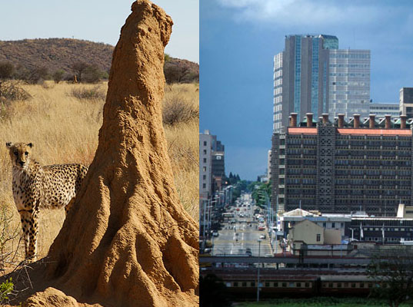
Eastgate Centre in Zimbabwe

The Eastgate Centre in Harare, Zimbabwe, although being the country’s largest office and shopping complex, is best known for having no conventional air-conditioning or heating. Instead, it stays regulated year round with a method inspired by the self-cooling mounds built by African termites.
Much like the mounds, the outside air that is drawn in by the mostly concrete building is either warmed or cooled by the building mass depending on which is hotter, the building concrete or the air. It is then vented into the building’s floors and offices before exiting via chimneys at the top. The complex also consists of two buildings side by side that are separated by an open space that is covered by glass and open to the local breezes. Air is continuously drawn from this open space by fans on the first floor. It is then pushed up vertical supply sections of ducts that are located in the central spine of each of the two buildings. The fresh air replaces stale air that rises and exits through exhaust ports in the ceilings of each floor. Ultimately it enters the exhaust section of the vertical ducts before it is flushed out of the building through chimneys. **

Kurt Rotering, PE,
Transportation Engineer
Affinis Corporation.

Kurt Rotering is a registered professional engineer and professional traffic operations engineer. He graduated from Kansas State University with a B.S. in Civil Engineering in 2007 and M.S. in Transportation Engineering in 2011. Kurt is currently working as a transportation engineering for Affinis Corporation in Overland Park, Kansas.
Tonight, Kurt will give a presentation titled “The Next Step”. It will cover information about Affinis and Consulting Engineers, what he does on a daily basis, what students should be doing to prepare, and what firms are looking for.

Enter for a chance to win a FREE TEXTBOOK! All you have to do is:
1) Email 3 interesting facts about yourself (one being why you chose to major in Civil Engineering) to
yaporras@k-state.edu.
2) If chosen, attend the assembly to present your three facts.
All those who participate in the “Student Spotlight” will be entered in a drawing to win a free textbook for the 2014 Fall semester! The drawing will take place on the last assembly of the semester.
Schedule

Sources:
*Sudoku puzzle from Sudokucollection.com
** http://inhabitat.com/building-modelled-on-termites-eastgate-centre-in-zimbabwe/
Scholarships

March 17th, 2014:
- Patti Johnson Wilson Foundation Scholarship
  - The Patti Johnson Wilson Foundation grants scholarships to undergraduate students majoring in Music, Engineering or Liberal Arts. The Trustees prefer that applicants work at least 10 hours per week. The MINIMUM undergraduate grade point average is 3.5 (on a 4 point system). Last year, the scholarship awards were $3,000-$4,000. These scholarships are restricted to sophomore, junior, and senior undergraduates.

May 1st, 2014:
- Kansas Chapter of the American Public Works Association: Steve Webb Memorial Scholarship

Internships/Jobs
Riley County Summer Internship
GBA

For more information on these scholarships and internships, visit http://www.engg.ksu.edu/asce/ and click on the “Bulletin Board” tab.
Scholarships/Internships

March 6 | Assembly | Water 231
March 11 | Tour | Water Treatment  Plant
April 4-5 | Open House
April 17 | Assembly | TBA
May 1 | Assembly | TBA
DATES SUBJECT TO CHANGE

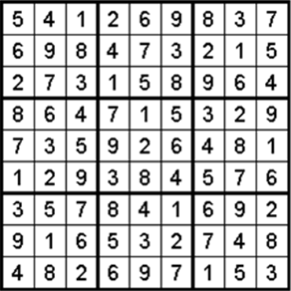

Fold and tear here
----------------------------------------------------------------------------------------------------
Name: _________________________________________
Class Rank: FR SO JR SR (circle one)
Date: March 6, 2014

Student Member: Y / N (circle one)
National Member: Y / N (circle one)
National Number: _______________________

