**Introductions:**

Practitioner Advisors: Dave Karnowski

Peter Clark

Honorary Lifetime

Contact Member: Bob Thorn

Faculty Advisors: Dr. Melhem

Dr. Riding

**Officer Reports:**

President: Jennifer Sommerfeld

*jsommer@ksu.edu*

Vice President: Vincent Studer

*studerv@ksu.edu*

Treasurer: Carl Peterson

*cjpeters@ksu.edu*

Secretary: Claudia Gonzalez

*claudi1@ksu.edu*

Editor/Historian: Katie Walbridge

*katiewal@ksu.edu*

Freshman/Sophomore Rep: David Laurence

*davlaur@ksu.edu*

Activities/Projects Chair: Noura Saadi

*nsaadi@ksu.edu*

Steel Bridge Chairs: Robert Schweiger

*rschwei2@ksu.edu*

Cale Armstrong

*cagolf91@ksu.edu*

Concrete Canoe Chairs: Katlyn Dotson

*kattydid@ksu.edu*

Nathan Pohl

*pohl@ksu.edu*

Open House Chairs: Ben Nye

*nye@ksu.edu*

Nicholas Clow

*nickclow@ksu.edu*

**Agenda:**

Announcements: Jennifer Sommerfeld

Introduction of Speaker: Vince Studer

Speaker: Senior Design & Officer Elections

In This Issue:

1. Tonight’s agenda

Sudoku

Important Information

1. Speaker Profile

ASCE Structure Profile

Schedule

Sudoku Answers

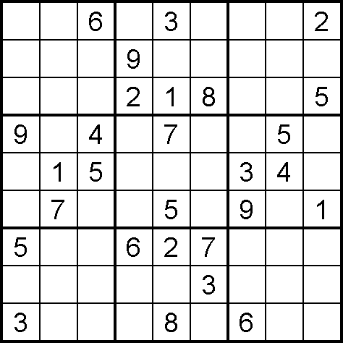

(Puzzle from Sudoku Collection:

www.sudokucollection.com)

Important Information

**FE Review** manuals are available for purchase with a discount promo code. Contact Carl Peterson if you are interested in purchasing the manual.

**Students must become national members to receive credit** for ASCE Student Membership. Registration is free and can be done online at http://www.asce.org/

Click “login” at the top of the page, then click “click here to create one” and follow the instructions to become a national member.



**Senior Design and Officer Elections**



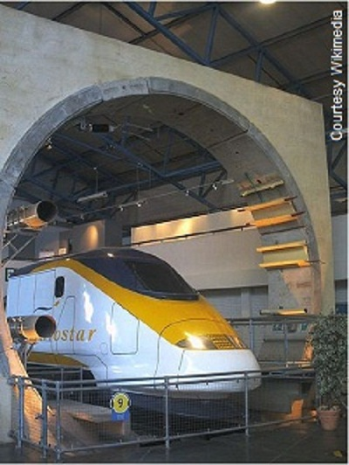

**Channel Tunnel**

The 31-mile [Channel Tunnel](http://www.asce.org/Featured-Images/Channel-Tunnel/)(Chunnel) fulfilled a centuries-old dream by linking Britain and the rest of Europe. More than a tunnel, it combines infrastructure and immense machinery in an underwater system of unprecedented ambition. Three 5-feet thick concrete tubes plunge into the earth at Coquelles, France, and burrow through the chalky basement of the English Channel. They reemerge behind the white cliffs of Dover at Folkstone.   
  
Through two of the tubes rush the broadest trains ever built. The double decker behemoths, which span 14-feet across, traverse the tunnel at close to 100 mph. Passengers board not on foot, but in automobiles and buses. Maintenance and emergency vehicles utilize the third tunnel, located between the rail tubes.   
  
Huge pistons open and close ducts, relieving the pressure that builds ahead of the trains' noses. Some 300 miles of cold water piping run alongside the rail tracks to drain off the heat raised by the air friction.

Information acquired from ASCE website, Seven Wonders

Schedule

|  |  |  |  |
| --- | --- | --- | --- |
|  |  |  | 7:00 PM |
|  |  |  | TBD |
|  |  |  | 7:00 PM |
|  |  |  |  |
| November 21 | **Assembly** | Umberger 105 | 7:00 PM |
|  |  |  | 7:00 PM |
|  |  |  |  |
|  |  |  | 7:00 PM |
|  |  |  | 7:00 PM |