Welcome to Assembly

October 30, 2014

In This Issue:
- Tonight’s agenda:
Speaking: HNTB- Cameron McGown and Kyle Berg
- Announcements
- Fall 2014 Officer Contacts
And Daily puzzles

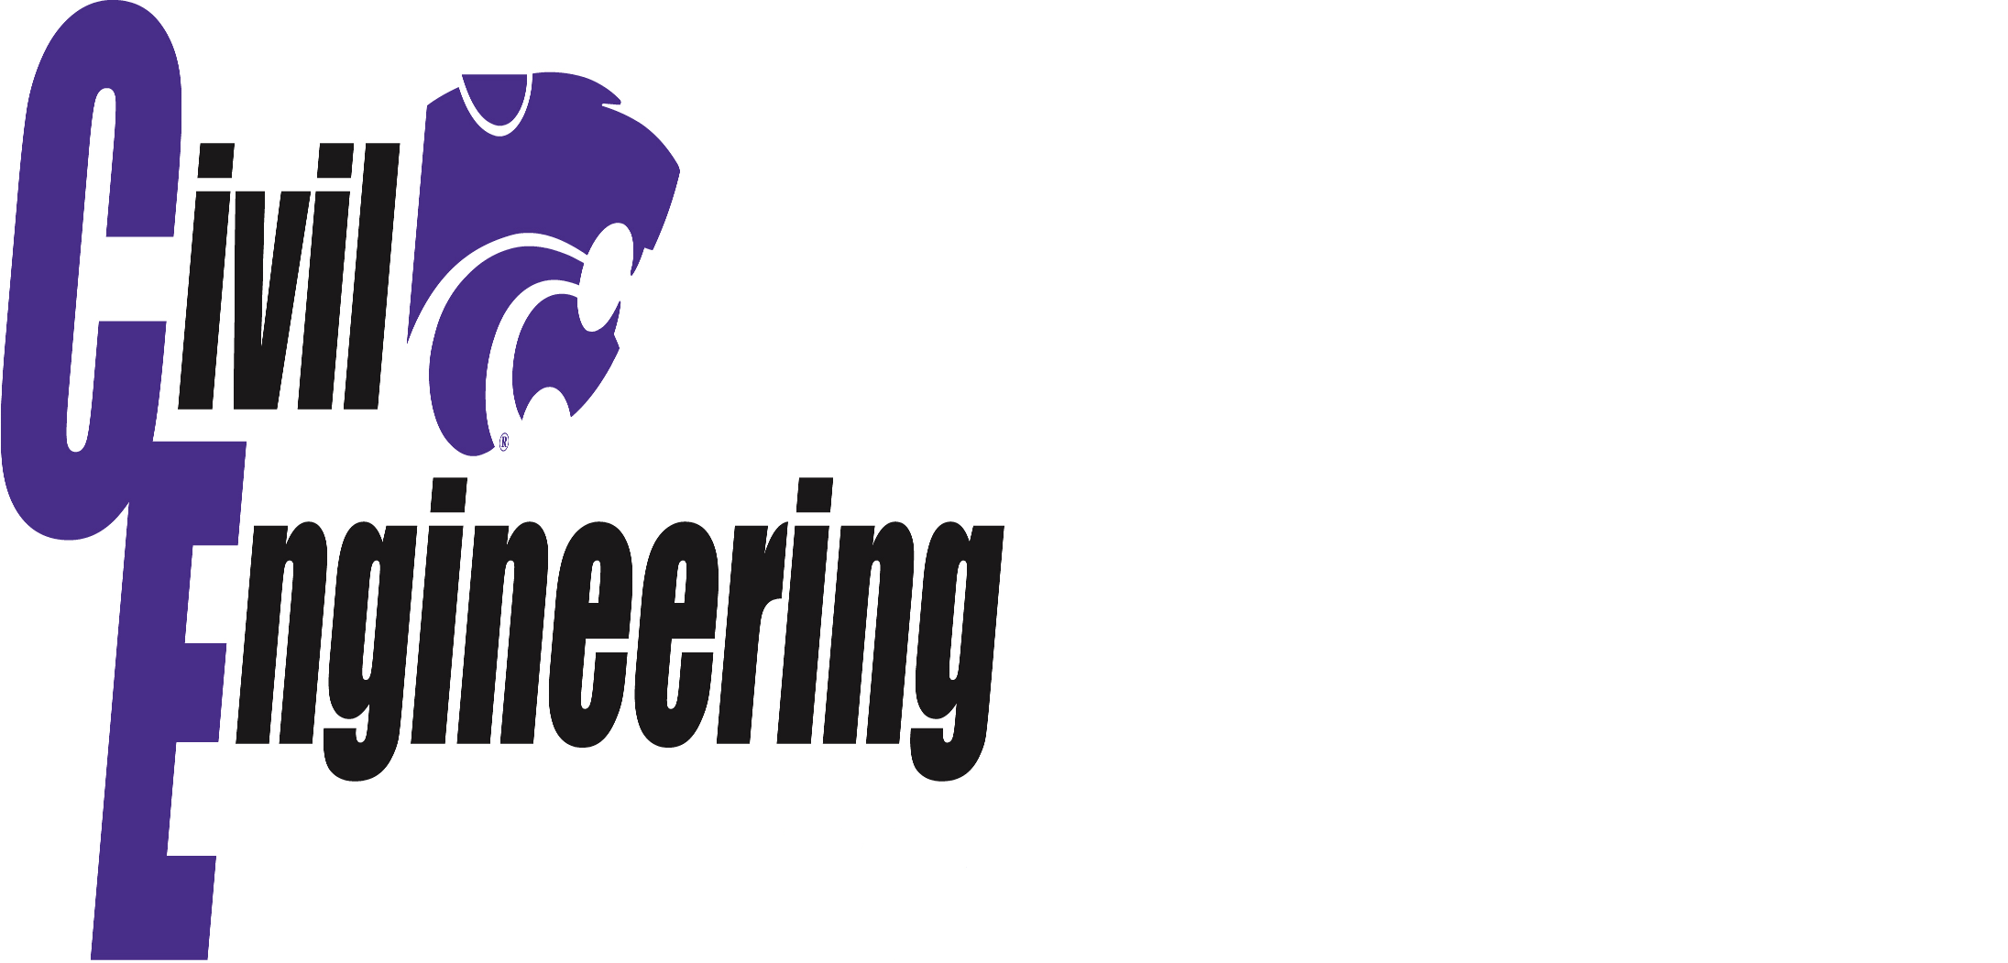
Speaker(s) Profile:

Cameron McGown joined HNTB in 2003 after graduating with a BS in Civil Engineering from Kansas State University in 2002. Cameron is a department manager in the KC Metro’s transportation group. He has been project or deputy manager for the planning and design of many street and highway projects in the Kansas City and Overland Park area. Such projects include 167th Street (Antioch to Metcalf), U.S. 69 and 159th Street Improvements, I-435/I-35/K-10 Interchange, I-435 and U.S. 69 Interchange Reconstruction and I-35 Bus Rapid Transit (BRT) with Bus on Shoulder Operations.

Kyle Berg joined HNTB in 2008 after graduating with a BS in Civil Engineering from Kansas State University in 2008. He received his Masters of Civil Engineering from the University of Kansas in 2012. Kyle is an engineer in the KC Metro’s bridge and structures group. His experience includes design on a variety of types of bridges as well as miscellaneous structures in Kansas, Missouri, Texas, Ohio and Virginia. Such projects include K-10/South Lawrence Trafficway, K-18 from Ogden to Manhattan and I-435/U.S. 69 Improvements in Overland Park, Kansas.

Did You Know?
In 1975, the Banqiao Dam in China was among many dams that were destroyed after the extreme rains of Typhoon Nina. It is estimated that between 90000 and 230000 lives were lost as a result of the Banqiao Dam breaking.

Fall ASCE Tentative Schedule

October 30- Assembly in Umberger 105
- HNTB
November 1- Joint Diner at KSU
- KDOT-Calvin Reed
November 20- Assembly in Umberger 105
- Senior Projects
- Officer Elections

IMPORTANT:

CE 015 Grading
To earn credit for CE 015, students who are not members of the K-State Student Chapter of ASCE must attend a minimum of five Civil Engineering Assembly meetings, or attend a minimum of four assembly meetings and actively participate in at least one of the following activities:
1. ASCE Concrete Canoe Team
2. ASCE Steel Bridge Team
3. College of Engineering Open House
4. “Other” activities as approved by the course instructors
Members of the K-State Student Chapter of ASCE must attend a minimum of four Civil Engineering Assemblymeetings, or attend a minimum of three assembly meetings and actively participate in at least one of the four activities listed above. Students must turn in a signature card at the assembly to receive credit for attendance.

To learn more, please see the CE 015 course syllabus and CE 015 Policies.

In order to receive credit for CE assembly, make sure that you are enrolled in CE 015- Class Number:10626

BrainBashers Daily Bridges
- Objective/Rules
- You have a collection of islands, each of which contains a number.
- This number shows you how many bridges leave that island.
- Your task is to connect every island, such that any island can be reached from any other.
- A maximum of two bridges can connect two islands together.
- Bridges can only go horizontally or vertically and may not cross each other.

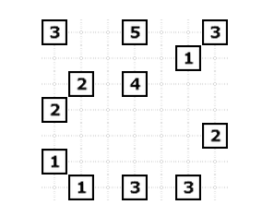
Introductions:
Practitioner Advisors: Dave Karnowski
Peter Clark
Honorary Lifetime
Contact Member: Bob Thorn
Faculty Advisors: Dr. Esmaeily
Dr. Riding
Officer Contacts:
President: Vincent Studer
studerv@ksu.edu
Vice President: Claudia Gonzalez
claudi1@ksu.edu
Treasurer: Jacob Paperi
jpaperi@ksu.edu
Secretary: Bryan Harkrader
bhark@ksu.edu
Editor/Historian: Yadira Porras
yaporras@ksu.edu
Freshman/Sophomore Rep: Brett Morey
bmorey@ksu.edu
Activities/Projects Chair: Mary Madden
marymadden@ksu.edu
Caleb Mitchell
caleb7@ksu.edu
Grad Representative: Andrew Bernica
abernica@ksu.edu
Steel Bridge Chairs: Eric Hamilton
eric29@ksu.edu
Donald Powers
dlpowers@ksu.edu
Concrete Canoe Chairs: Jacquelyn Ewald
jkewald@ksu.edu
Darren Meyer
djmeyer@ksu.edu
Open House Chairs: Ben Nye
nye@ksu.edu
Koby Slaven
kslaven@ksu.edu
George Baker
georgefbaker@ksu.edu

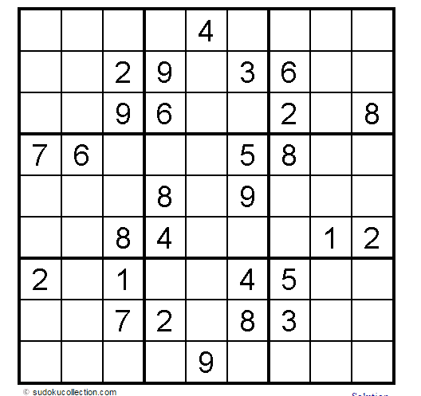

Show off your art skills and try to draw the Guggenheim Museum shown on the bottom left hand corner!

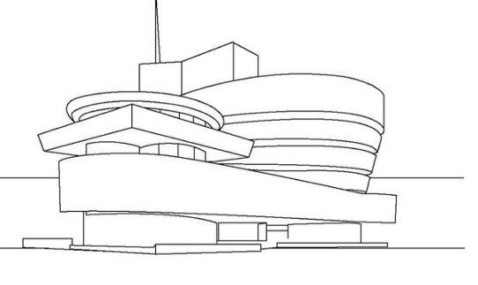

Scholarship
- Wichita Branch ASCE Scholarship​
The Wichita Branch R. Spencer Delamater, P.E. Scholarship was established in 1999 for the purpose of inspiring civil engineering students to high achievement in both academic and leadership development. The $1,000 scholarship for the Spring 2015 semester is available to a Kansas State University or a University of Kansas civil engineering junior or senior from the 37 county area the Wichita Branch serves.

For more details visit the KSU ASCE website under our bulletin board!
​APPLICATION DEADLINE IS OCTOBER 31, 2014

Attention: KSU Civil Engineering Students - If you are interested in gaining experience in Design, Road and/or Bridge, Kansas Department of Transportation has openings for students interested in transportation to work near campus this spring semester. The location is at the north end of Manhattan Ave, just south of Kimball, in the NEW Department of Agriculture Building. KDOT has a design squad within our Local Projects section in this building. If anyone is interested, please contact the engineering recruiter, Debbie Wallace, at debbiewa@ksdot.org for more details.

KDOT plans to conduct interviews at the Manhattan Office on Monday, November 17th and Tuesday, November 18^{th.}

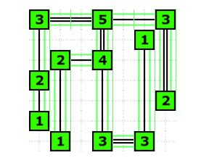

Solution to the puzzle bridge:

Fold and tear here

-------------------------------------------------------------------------------------
Name: _________________________________________
Class Rank: FR SO JR SR (circle one)
Date: October 30, 2014

Student Member: Y / N (circle one)
National Member: Y / N (circle one)
National Number: ____________________________

