In This Issue:

1. Tonight’s agenda

Sudoku

Important Information

1. Speaker Profile

Structure Profile

1. Scholarships/Internships

Schedule

Sudoku Answers

**Introductions:**

Practitioner Advisors: Dave Karnowski

Peter Clark

Honorary Lifetime

Contact Member: Bob Thorn

Faculty Advisors: Dr. Melhem

Dr. Riding

**Officer Reports:**

President: Jennifer Sommerfeld

*jsommer@ksu.edu*

Vice President: Vincent Studer

*studerv@ksu.edu*

Treasurer: James Scott

*jamesds@ksu.edu*

Secretary: Michael Stancic

*sumadinac@ksu.edu*

Editor/Historian: Claudia Gonzalez

*claudi1@ksu.edu*

Freshman/Sophomore Rep: Yadira Porras

*yaporras@ksu.edu* Activities/Projects Chair: Noura Saadi

*nsaadi@ksu.edu*

Steel Bridge Chairs: Robert Schweiger

*rschwei2@ksu.edu*

Cale Armstrong

*cagolf91@ksu.edu*

Concrete Canoe Chairs: Katlyn Dotson

*kattydid@ksu.edu*

Nathan Pohl

*pohl@ksu.edu*

Open House Chairs: Ben Nye

*nye@ksu.edu*

Nicholas Clow

*nickclow@ksu.edu*

Caleb Mitchell

*caleb7@ksu.edu*

**Agenda:**

Announcements: Jennifer Sommerfeld

Introduction of Speaker: Vince Studer

Speaker: Bob Ringer

Corrugated Steel Pipe Association

Important Information

**Students must become national members to receive credit for ASCE Student Membership.** Registration is free and can be done online at http://www.asce.org/

Click “login” at the top of the page, then click “click here to create one” and follow the instructions to become a national member.

**If you are not currently enrolled in CE015, please do so in order to receive credit for attendance. Class Number: 10581**

**FE Review** manuals are available for purchase. Contact James Scott if you are interested in purchasing the manual.

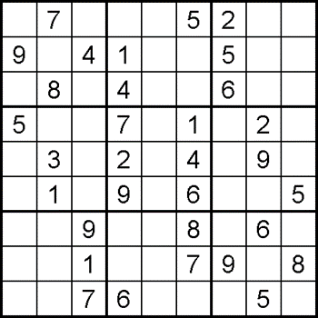

*

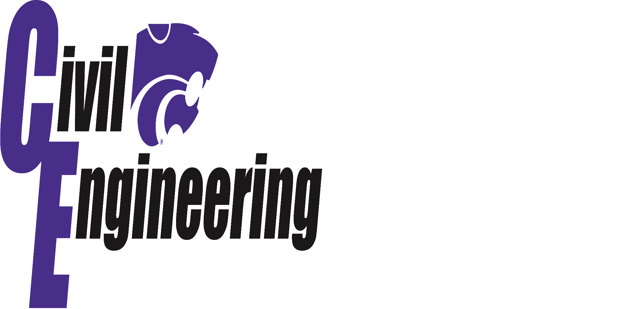

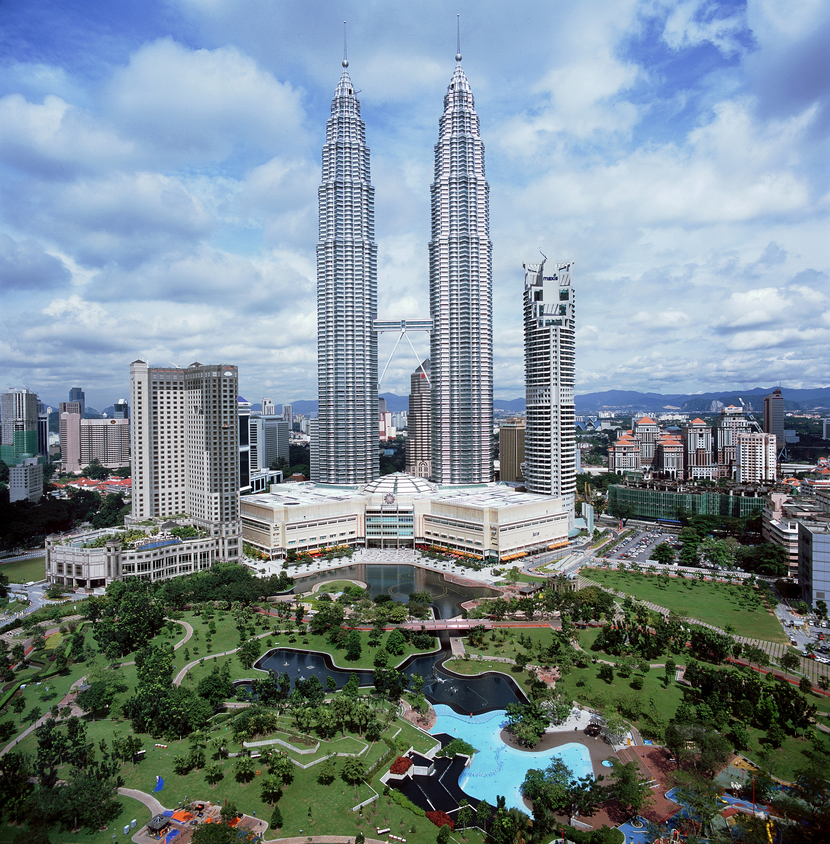**\*\***

**The Petronas Twin Towers**

The Petronas Twin Towers are the twin skyscrapers in Kuala Lumpur, Malaysia. The 88 floor building, whose construction date started in 1993, took three years and cost approximately $1.6 billion to build. In order to meet the 6 year deadline, two construction consortiums were hired where each was assigned a tower. The towers held the title for the tallest buildings in the world until 2004 but still remain the tallest twin buildings in the world to this day.

The construction of the two buildings had its fair share of setbacks. For example, after discovering that half of the original site was decayed limestone, the entire site was moved 200ft so it would all be able to sit on soft rock. The depth of the bedrock caused the buildings to be built on the world’s deepest foundation. The concrete raft foundation, comprised of 470,000 cubic feet, was poured continuously on each tower for 54 hours. Until 2007, it held the title for the largest concrete pour.

Another problem that had occurred during the build was that Tower 1 was discovered to be leaning .98 inches off from vertical. In order to balance it out, the next 16 floors were set to lean .79 inches.

***

**Bob Ringer, PE**

National Corrugated Steel Pipe Association

College Presenter

Bob Ringer holds a Master’s Degree in Engineering from the University of New Mexico. Bob worked for the New Mexico Department of Transportation for 25 years. For the past 14 years Bob had been doing educational presentations on corrugated steel pipe at leading engineering schools in the Western United States. Bob is the college presenter for the National Corrugated Steel Pipe Association sponsored by the South Central Corrugated Steel Pipe Association.

Topics covered tonight will include an introduction and advanced information on corrugated steel pipe design and installation. Also, engineering principles, construction techniques, storm water detention, environmental issues and special uses.

Each student will receive a postcard that can be mailed to obtain the **new**, 624-page Corrugated Steel Pipe Design Manual or a flash drive of the manual which is an excellent engineering reference manual for drainage projects. It contains advanced information on hydrology, hydraulics, storm water management and water quality, durability, and maintenance and rehabilitation of drainage structures.

Scholarships/Internships

**Scholarships**

*February 1st, 2014:*

[**General KSU College of Engineering Scholarship**](https://apply.k-state.edu/app/open/SFALanding_open.action)

*March 1st, 2014:*

[**Kansas Chapter of the American Concrete Institute 2014 Scholarship**](https://www.engg.ksu.edu/asce/files/asce/files/Bulletin%20Board/ACI%20Scholarship%202014.pdf)

The applicant must maintain a 2.5 or above grade point average.

The applicant must not have failed any classes 3

The applicant must be a full time student with a minimum class load of twelve (12) hours.

An applicant who has already been awarded a scholarship from the Kansas Chapter/American Concrete Institute may not apply for a second scholarship.

[**2014 National Daniel W. Mead Student Contest**](http://www.asce.org/Content.aspx?id=23622327580)

*Entries for the contest shall be limited to one paper from each ASCE or AEI Student Organization and must be submitted through the Faculty Advisor.* Authors must be undergraduate students, Student Organization members in good standing, and ASCE and/or AEI members in good standing at the time of submission and at the time the award is made to be considered. Entries should include a cover letter from the Faculty Advisor stating the name, ASCE/AEI member ID number, mailing address, phone number, and e-mail of the paper's author. Send entries to [student@asce.org](mailto:student@asce.org).

*May 1st, 2014:*

[**Kansas Chapter of the American Public Works Association: Steve Webb Memorial Scholarship**](https://kstatedce.wufoo.com/forms/ks-chapter-apwa-steve-webb-memorial-scholarship/)

Applicants must be enrolled as an undergraduate student at Kansas State University in a curriculum which could possibly lead to a career in Public Works. Preference will be given for Civil Engineering students.

Applicant must be in good academic standing with respect to the requirements established by the School of Engineering at the University.

Applicant must be classified as a junior or senior for the year in which they receive the scholarship and must be enrolled in a minimum of 12 credit hours each semester.

**Internships/Jobs**

[Riley County Summer Internship](http://www.rileycountyks.gov/jobs)

**For more information on these scholarships and internships, visit** [**http://www.engg.ksu.edu/asce/**](http://www.engg.ksu.edu/asce/) **and click on the “Bulletin Board” tab.**

Schedule

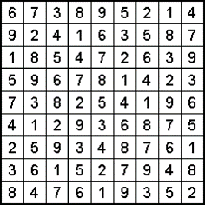

|  |  |  |
| --- | --- | --- |
| January 30 | **Assembly** | Umberger 105 |
| February 6 | **Assembly** | Umberger 105 |
| February 11-12 | **Career Fair** | Student Union |
| February 20 | **Assembly** | Umberger 105 |
| March 6 | **Assembly** | Umberger 105 |
| March 27 | **Spring Picnic** | TBD |
| April 4-5 | **Open House** |  |
| April 17 | **Assembly** | Umberger 105 |
| May 1 | **Assembly** | Umberger 105 |

**DATES SUBJECT TO CHANGE**

|  |  |
| --- | --- |
|  |  |

**Sources:**\*Sudoku puzzle from sudokucollection.com   
**http://www.faculty.fairfield.edu/faculty/hodgson/Courses/so191/Projects2010/Bendan_Buzaid/petronas2.jpg  
***http://en.wikipedia.org/wiki/Petronas_Towers