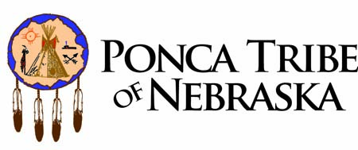

BROWNFIELDS - TRIBAL RESPONSE PROGRAM TRAINING
by TAB Program at Kansas State University
at Ponca of Tribe of Nebraska
Lincoln, NE
May 21 – 23, 2012

WHAT:
- Interactive training workshop with lecture alternating with Tribal success stories / challenges, discussion, and practical exercises.
- Handouts will include useful checklists, key presentation slides, and examples of documents.

WHERE: Tribal Offices of the Ponca Tribe of Nebraska; 1701 E Street Lincoln, NE 68508
402-438-9222 (Parking is available in the back and along sides of the building)

TOPICS:
Monday May 21 (Day 1 – half day)
Morning - Optional Work Sessions

Afternoon (1:00 – 5:00)
  - Overview of Workshop Topics and how they fit into TRPs
  - Phase 1 Environmental Assessments: preliminary steps before starting, work to meet AAI and Fee to Trust requirements
  - Tribal success stories / challenges
  - Practical exercise with checklists
  - Phase II Environmental Assessments: contracting process, RFPs, DQOs, QAPPs, Reports
  - Exercise

Tuesday May 22 (Day 2)
Morning (8:30 – 12:00)
  - Establishing Cleanup Standards / Decision Making Process (including exercise)

Afternoon (1:30 – 5:30)
  - Cleanup Approval Process, Verification and Certification
  - TRP Contracting

Wednesday May 23 (Day 3 - half day)
Morning (8:30 – 12:00)
  - Development & Application of Tribal Codes/Ordinances

Afternoon - Optional Work Sessions

