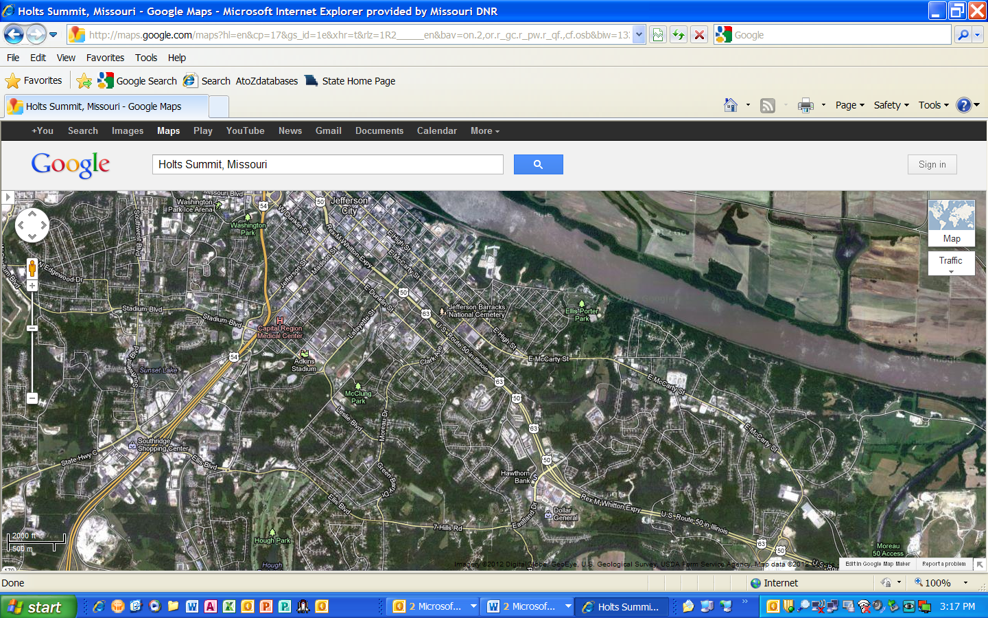
North

To get to our office at 1730 East Elm Street (yellow arrow):
From Highway 54 south of town:
- Take the Ellis Blvd exit and turn right>
- Take Ellis Blvd (which changes to 7 Hills Road which changes to Eastland Drive)
- Travel about 2.5 to 3 miles total
- Turn left on East Elm Street next to the Walgreens.
- (If you get to Highway 50/63 you JUST passed Elm Street – turn around.)
- Travel around the “S” curve on East Elm Street and head down the hill to our building on the left.

If coming from Hwy 50/63/Whitton Expressway just East of downtown:
- Take Eastland exit and turn South (towards the McDonalds)
- Turn right immediately (before Walgreens) onto East Elm St.
- Travel around the “S” curve on East Elm Street and head down the hill to our building on the left.
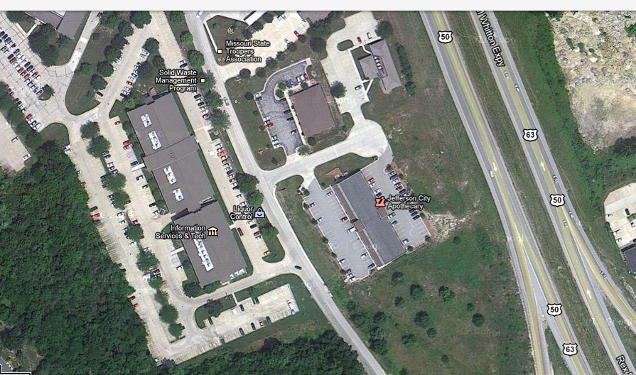
There are two driveways to the building (red arrows). You can take either drive just head to the rear of the building. We are the West end of the building 1730. Entrance is the blue arrow. All other doors require a security pass.
Park wherever you can find a spot even if it says employee parking only.

